**Car Dealership System**

**Lab – 09: Windows Navigation Diagram**

**Group Number: 02**

**Group Members:**

|  |  |
| --- | --- |
| Student Id | Student Name |
| 19101069 | Md. Mahbubur Rahman Raad |
| 19101088 | Md. Mehtabul Islam Shafin |
| 19101076 | Sayem Kader Chowdhury |

Date of Submission: 6th May 2021

**Windows Navigation Diagram:**

Window navigation diagrams model the navigation paths between the windows in a GUI (Graphical User Interface) or the pages of a Web site. Our Windows Navigation System shows the windows, forms and one pop-up window which comprises our website.

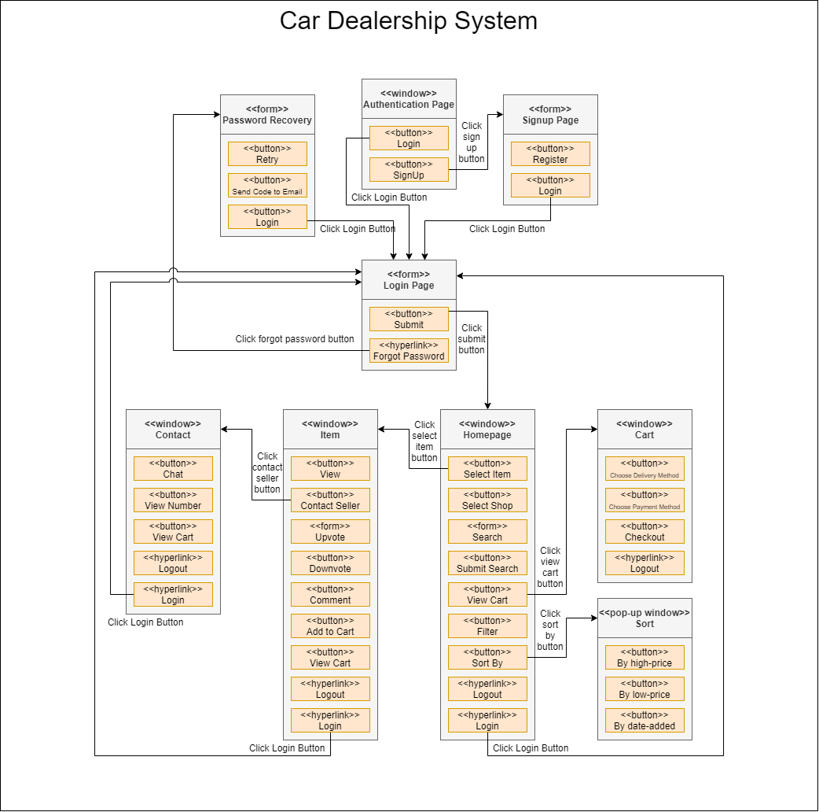

*Figure 1.0: Windows Navigation Diagram*